**Building a static website with S3**

Step1: Created one static application in vs code.

Step2: Create 1 bucket in AWS S3

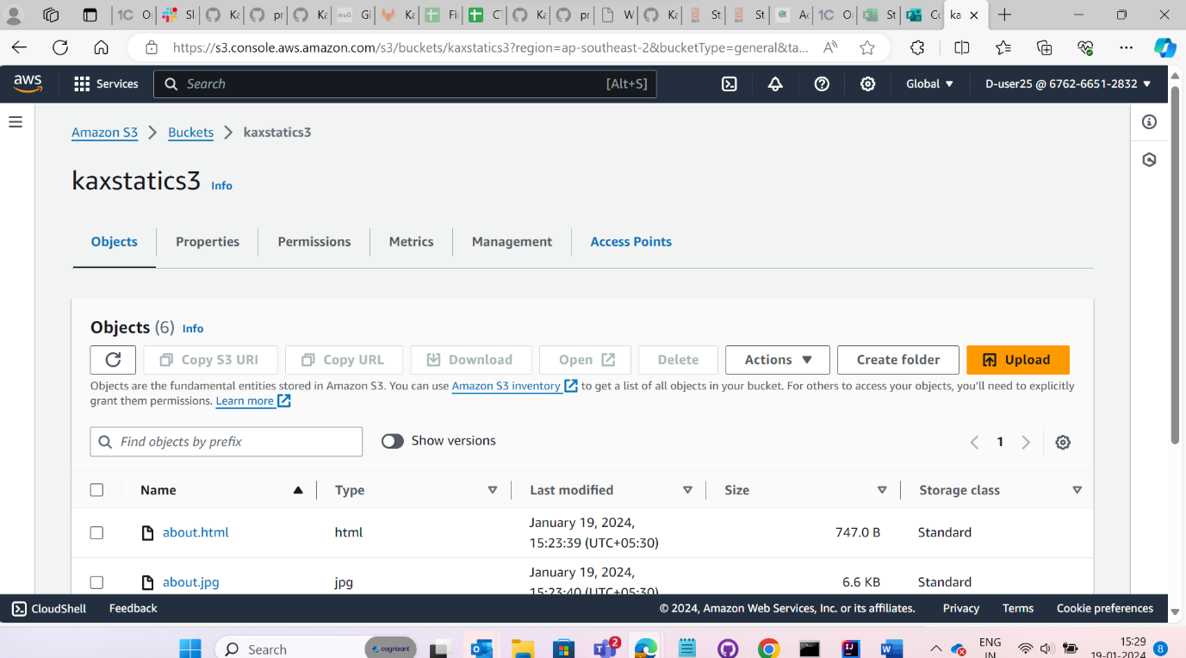

Step 3: upload the files in the S3 bucket

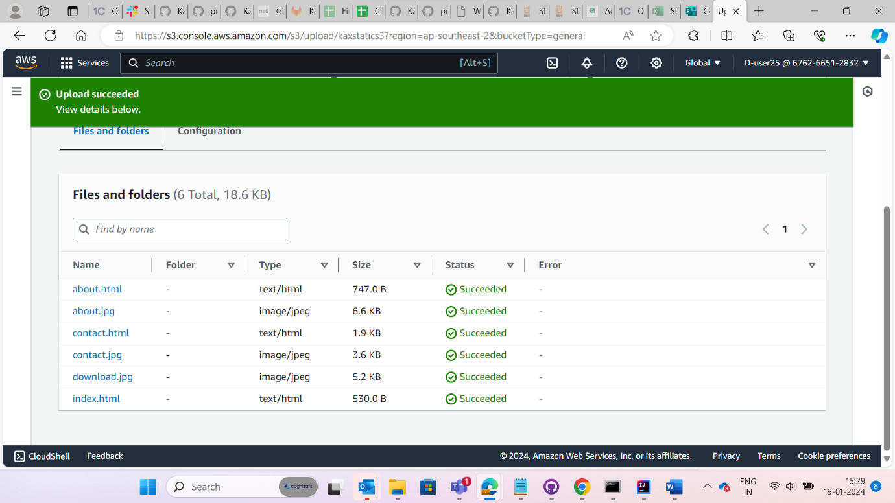

Step 4: Add bucket policies in permission

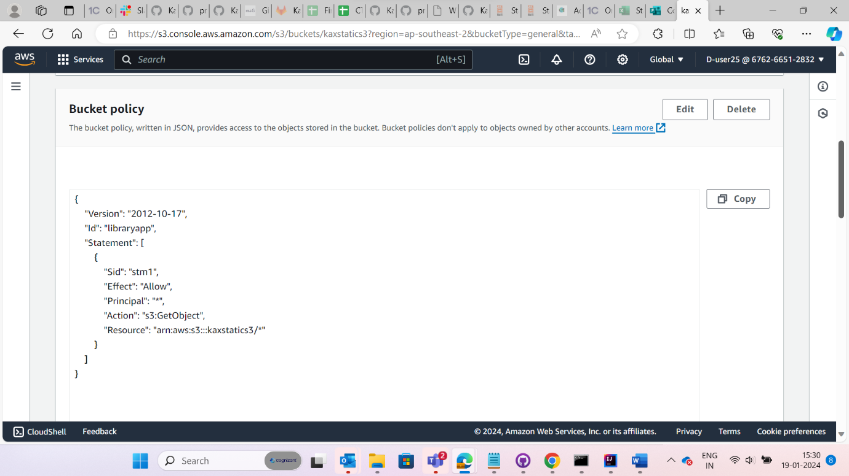

Step 5: Go to properties you will find static link

Step6: walk through the link

